Robotaxi Modelling Notes
Christopher Kalitin

Finding Datasets

https://grok.com/chat/90c2b8f4-f357-468e-969e-17abea37e13d

US National Origin-Destination (OD) Data:
https://nhts.ornl.gov/od/
Yea this is everything I need. (Except public transport) (And intraday)

National Household Travel Survey:
https://nhts.ornl.gov/
Breakdown of start time of trip (intraday) and mode (car, transit, etc.).
Note that column definition is under documentation tab on top.

US Census (percentage data, not absolute):
https://www.census.gov/content/dam/Census/library/publications/2021/acs/acs-48.pdf
https://www2.census.gov/library/publications/2024/demo/acsbr-018.pdf
This can be used to extrapolate public transit usage.

Trips by driver survey (breakdown by age, etc.):
This provides a good sanity check
https://aaafoundation.org/wp-content/uploads/2024/08/202408-AAAFTS-American-Driving-Survey-2023.pdf

Note that every pdf and dataset should be downloaded to my PC

High-level Summary of Model

Independent variables to isolate for are:
- Mode of transport
- Trip time / length
- Trip Purpose (commute, errand, leisure, etc. some are more elastic)
- Time of day
- Cost of trip type (car, transit, plane, etc.)
- Passengers in vehicle (trips vs. person trips)
- Weather (apparently Uber sees 30% more demand in rain?)

I’ll be using a static dataset indexed on a single time, so broader decadal trends will have to be modelled separately.

What can be modelled separately is high-level decadal trends in transport (eg. train market share). Also fleet dynamics (utilization, charging downtime, empty miles (Waymo’s apparently 30-40%).

Datasets required:
- Car, transit, plane, walking trips by time of day and length
- Ride hailing market penetration in given geographies
- Commercial transport volume and rates by mode (truck, rail, plane)

Model Goals

Net output: Market cap of robotaxi providers and market share of competing companies.

To get this I’ll need revenue per geography of each provider. To break down by provider I’ll have to make qualitative assumptions about market share and strategy.

To find revenue per geography I’ll need trips by type in each geography (work vs non-work, personal vehicle, transit, commercial, etc.) and cost of other forms of transport (personal car ownership, transit, etc.).

Then model customer elasticity somehow and derive market share from price and a customer model.

Vehicle, train, air, active and work/non-work is in the NHTS OD survey. No transit breakdown.

For transit, a more complex analysis of the transit business model is required to see if it survives robotaxis.

I can structure this as a series of blog post, progressively adding more real-world factors to the model, until the ultimate Transition to EV Robotaxi’s blog post. Well, it’ll never be a single ultimate blog post, always make marginal improvements.
I need to actually start working with the dataset to figure out what I’m going to do, or meditate or something like that.

Public Transit Elasticity

Arc elasticity: Marginal change in demand for a 1% change in price, stacking cumulatively on an ever changing base.
Ie. 1 * 99.6 * 99.6 * 99.6 … This results in an exponential function

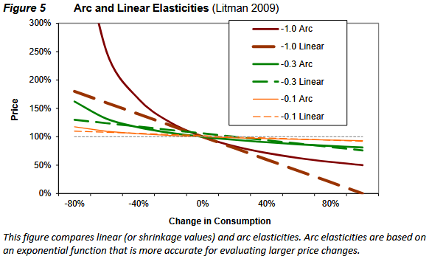

Notice how linear is suboptimal, obvious technique (Not taught in econ 101!!!)

Remember The Goal: Be Directionally Correct, And In The Right Order For Magnitude.

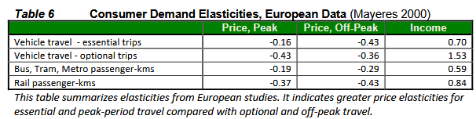

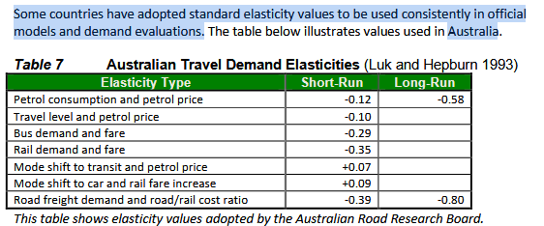

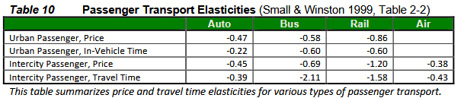

Maybe I can use these elasticity values in my analysis.

Aim For Functional Goals

Unanswered questions:
- Annual Revenue in the US
- Annual Revenue in the World (Breakdown by geography)
- Path to significant market share in high-income geographies
- Price of a robotaxi ride
- How big the fleet needs to be
- Competition with public transit

Most important is finding ride TAM, cost per ride, price per ride, and market share / price over time.

TAM is simple enough, cost per ride requires corollaries and a spreadsheet.

For tomorrow:
- Using OD data, get trips by intra-city, inter-city, inter-state. Also by distance and mode.
  - Just make the charts
  - Just from this and a $/km guess, you get a revenue TAM.
- Find the cost floor for robotaxi’s. Cost in the limit. Corralaries. Continually check assumptions.

Net US Trips (NHTS OD Data)

- Check if total trips (“estimated”) adds up to each individual trip type.
- Bin into chartable dataframe for trips by type by distance

Docs: https://nhts.ornl.gov/od/assets/doc/NextGen_NHTS_Passenger_OD_Data_Methodology_summary.pdf

Trips Types
- Air
  - Only airport-to-airport source / destination (eg. not the taxi to the airport).
- Rail
  - Includes all modes for a given rail trip (eg. also the taxi / walk to the station)
- Vehicle
  - Includes all vehicles, personally owned and public transit.
  - Vehicle trips can also include walking to a bus stop, taking a bus (but not rail), then walking to the final trip destination. AIUI this is a single trip.
- Active transport
  - Walking, biking, ferries of any distance (eg. 500m to corner store).

https://aaafoundation.org/wp-content/uploads/2024/08/202408-AAAFTS-American-Driving-Survey-2023.pdf

This gives a breakdown of trips per day by driver broken down into a few categories. It says 229 billion total trips in 2022 (driver trips by demographic times demographic population).

I get 313 billion from the NHTS survey and 230 Billion for 0-10 mile trips.

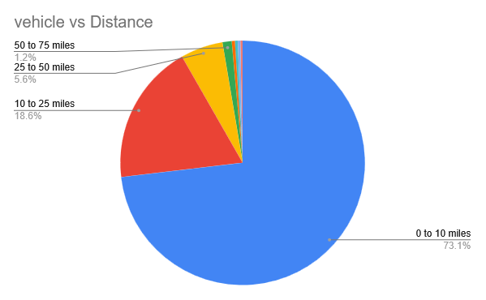

This isn’t granular enough data. I need a more precision distribution of trip length.

A first TAM attempt using $0.5 / mi and the middle of the length range (eg. 5 mi for 0-10 mi) I get a revenue TAM of around 2 trillion in the US.

For reference, automotive sales & parts is $1.5T / year.

Assume Tesla gets 50% market share and 10% profit margin on ride cost (all rides, including customers). This is 2T * 0.5 * 0.1 = $200B / year. Times 50 P/E you get $10T (P/E currently 200). Nice. Tesla is currently at ~4B gross profit per quarter.

At worst, I see a 5x in Tesla stock from this. Still a fuck ton of research to do though.

